Read Me
By Jodie Snodgrass
17 April 2026
CS 340

Describe the required functionality of the project. Include the screenshots or screencast taken while testing and deploying your dashboard (Step 6) as proof that you have achieved the required functionality.

This project allows authorized users to access a database composed of animals with their names, age, location, sex, DOB, breed, species, record number, and animal ID all information provided by the Austin Animal Shelter. Using The CRUD method I created a table with drop down options that the Grazioso Salvare Company required. The sorting options included reset which showed all animals in the database, dog type that would be good for water rescue, dog types that would be good for mountain or wilderness rescue, and dog types that would be good for disaster or individual tracking rescue. The table is interactive to see a certain animals location and what percentage of breeds are available for a certain rescue option in a pie chart.
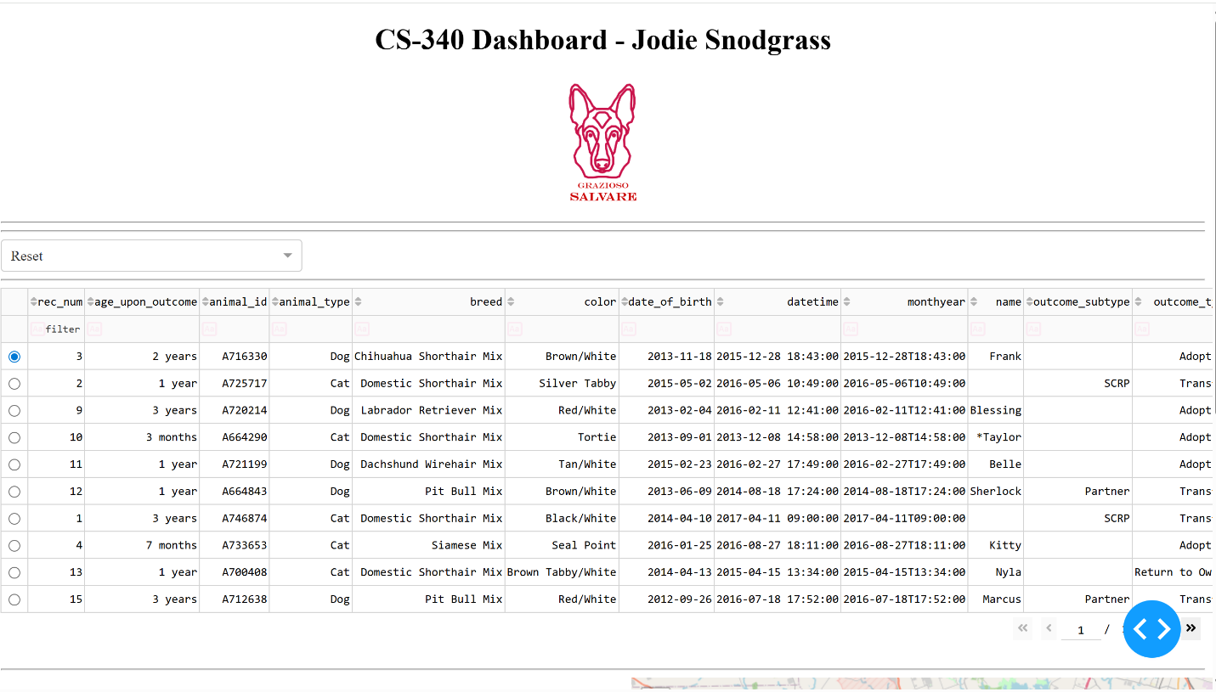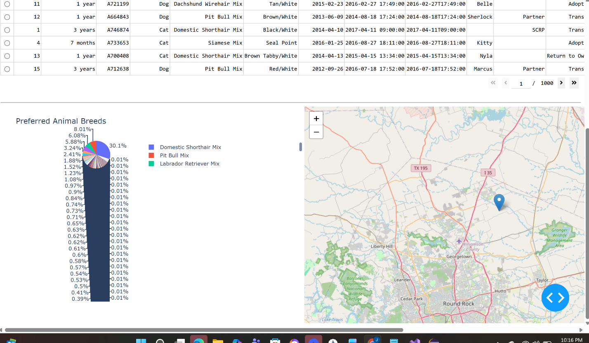
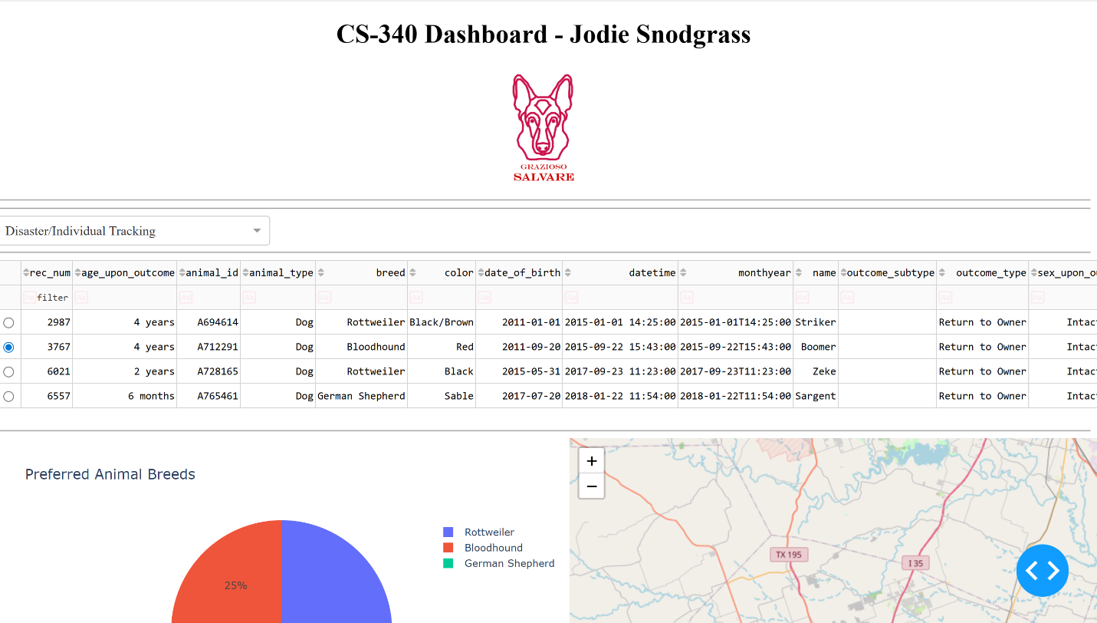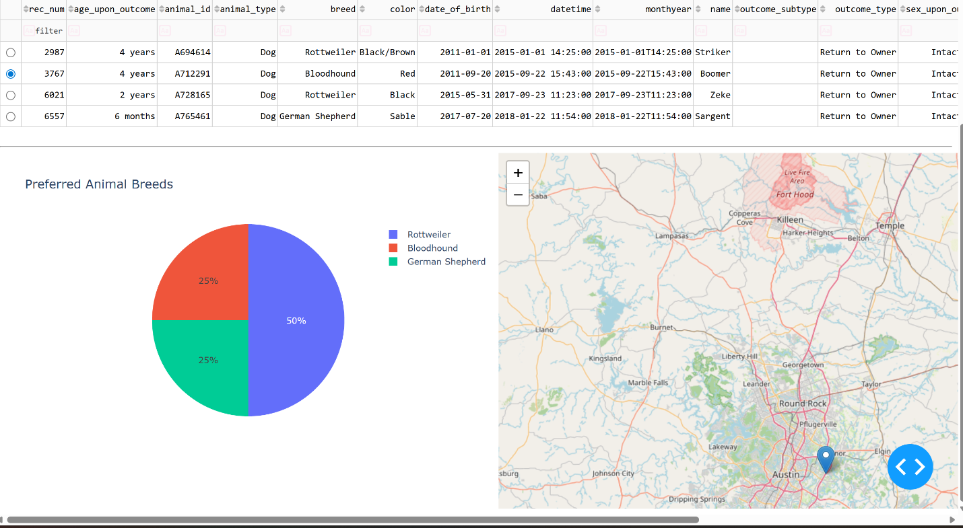
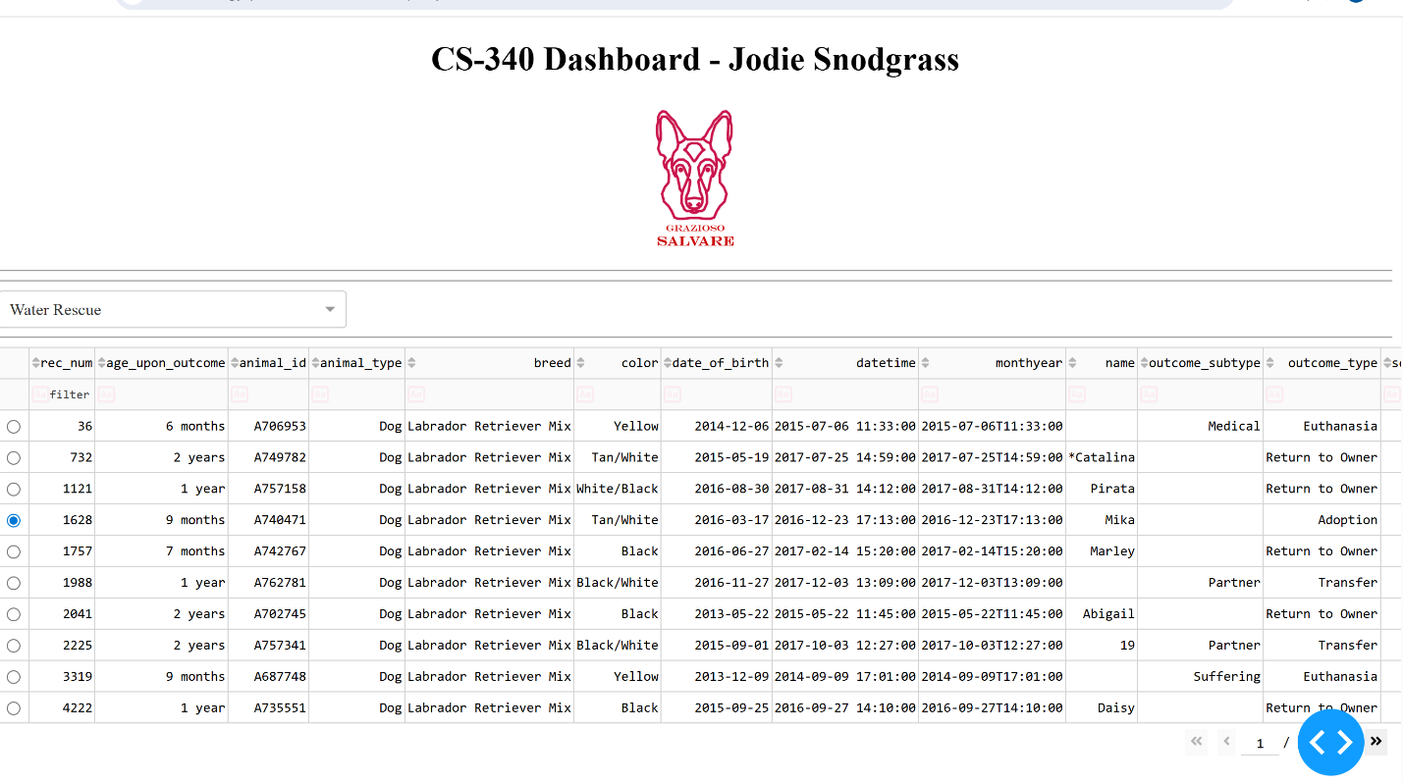
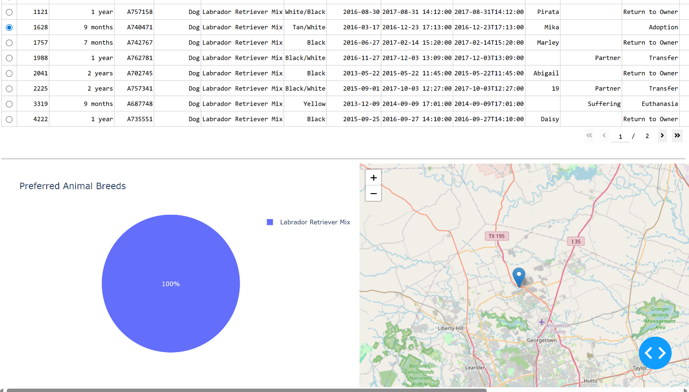
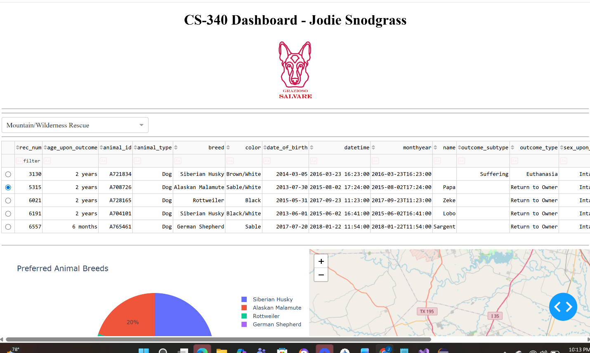
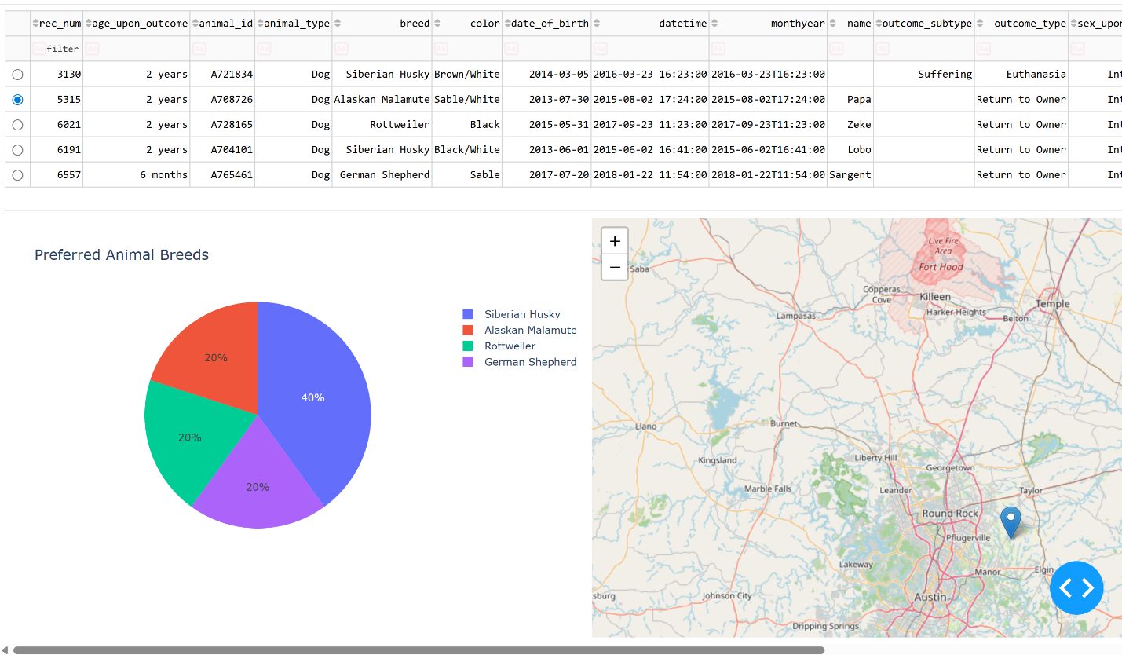

Describe the tools used to achieve this functionality and a rationale for why these tools were used.
MongoDB was used in this project to store all the data information. MongoDB was nice to use for this project for its flexibility, scalability, and versatility. Flexibility was needed for the python code in the project because I was able to change data structures quickly. Scalability was good for the project because of the large amount of data provided by the shelter can be available to many easily as long as they have credentials to login. Versatility is nice for the project to handle multiple different user profiles. Dash framework was used in this project to provide views and controllability to the web application. Dash framework provided the UI and allowed users to interact with the table, and filtering options.
Explain the steps that were taken to complete the project.
The project started by creating a database from information provided from a csv file provided by the shelters. The next step was creating user credentials to have access to the database. Once access was granted the next step was creating the CRUD class to alter the database. The next step was creating a table to display animal information in the UI. The final step was creating a way to filter animal information displayed in the table, make the table interactive by showing a certain animals geo-location, and the percentage of breeds in which ever filter is current displayed as a pie chart.
Identify any challenges that were encountered and explain how those challenges were overcome.
The first issue I experienced was the logo was not appearing in the UI. To solve the issue I realized that i missed putting in the code to display the image along with the dashboard title. The next issue was that I realized the image was way to large taking up so much of the screen that the table would not be seen on first glance. To solve this issue I set limits to the logo size so that title, logo, table, chart, and map can be seen at first glance. My last issue was my chart was appearing but my map was not. It was just very delayed appearing after the chart. I am unsure why originally it was so delayed but after a restart all was much faster.

